Lab3-Histogram

CIS694/EEC693 Image Processing and Learning Methods-2021 Spring

By Hongkai Yu, [h.yu19@csuohio.edu](mailto:h.yu19@csuohio.edu)

Cleveland State University

In this in-class lab, we will practice the Histogram Equalization algorithm for the image enhancement.

1. Please create a Matlab file named “histogram.m” to write a function *histogram* using a loop to compute the image histogram:

function h = histogram(imgname)

If you call this function in the console by

h = histogram("example.png");

It will show as follows:

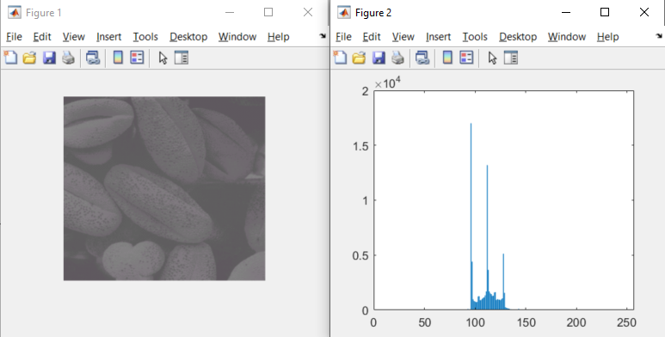

2. Please create a Matlab file named “histogram2.m” to write a function *histogram2* withoutusing a loop to compute the image histogram:

function h2 = histogram2(imgname)

If you call this function in the console by

h2 = histogram2("example.png");

It will show as follows:

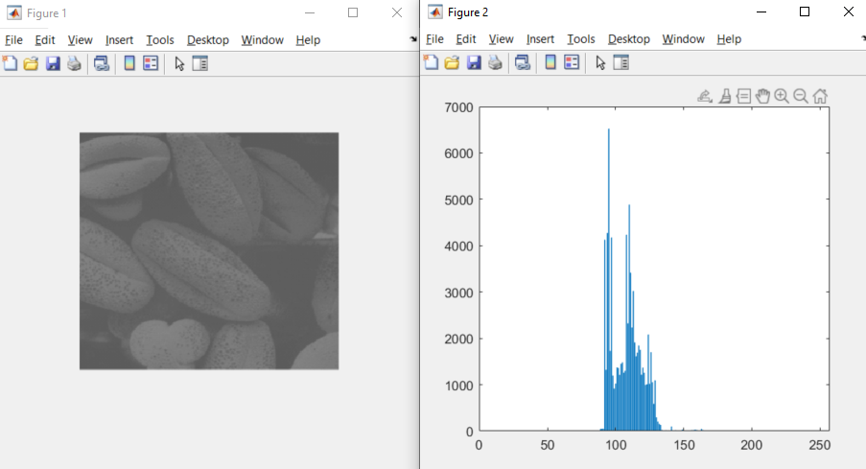

3. Write a Matlab code to compare the obtained *h* from Question1 and *h2* from Question2. Are they the same? Then, write a Matlab code to compute the normalized histogram.

4. Please create a Matlab file to implement the Histogram Equalization (HE) algorithm to enhance the image “example.png”. Running your code should show the following figures:

